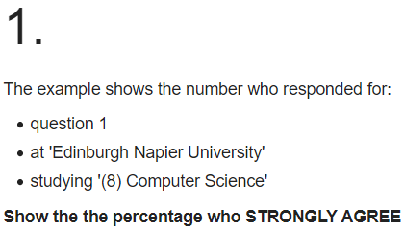

**SELECT A_STRONGLY_AGREE FROM nss WHERE question='Q01' AND institution='Edinburgh Napier University' AND subject='(8) Computer Science';**



**SELECT institution, subject FROM nss WHERE question='Q15' AND score >= 100;**

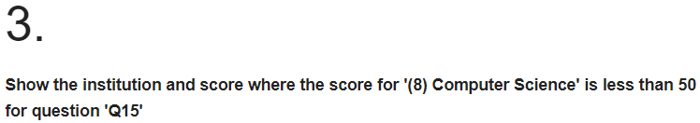

**SELECT institution,score FROM nss WHERE question='Q15'AND score < 50 AND subject='(8) Computer Science';**

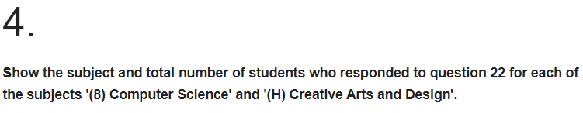

**SELECT subject, SUM(response) FROM nss WHERE question='Q22'AND (subject='(8) Computer Science' OR subject='(H) Creative Arts and Design') GROUP BY subject;**

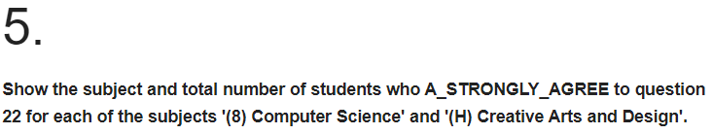

**SELECT subject, SUM(response * A_STRONGLY_AGREE / 100) FROM nss WHERE question='Q22' AND (subject='(8) Computer Science' OR subject='(H) Creative Arts and Design') GROUP BY subject;**

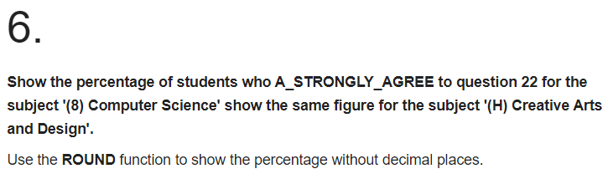

**SELECT subject,ROUND(SUM(response * A_STRONGLY_AGREE / 100) / SUM(response) * 100, 0) FROM nss WHERE question='Q22' AND (subject='(8) Computer Science' OR subject='(H) Creative Arts and Design') GROUP BY subject;**

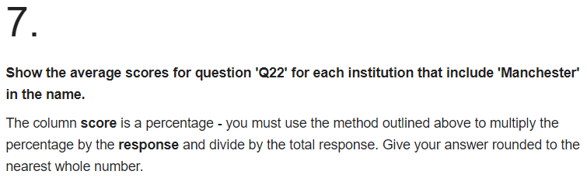

**SELECT institution, ROUND(SUM(score * response) / SUM(response), 0) FROM nss**

**WHERE question='Q22'AND (institution LIKE '%Manchester%') GROUP BY institution**

**ORDER BY institution;**



**SELECT institution, SUM(sample), (SELECT sample FROM nss y WHERE subject='(8) Computer Science' AND x.institution = y.institution AND question='Q01') AS comp**

**FROM nss x WHERE question='Q01' AND (institution LIKE '%Manchester%') GROUP BY institution;**